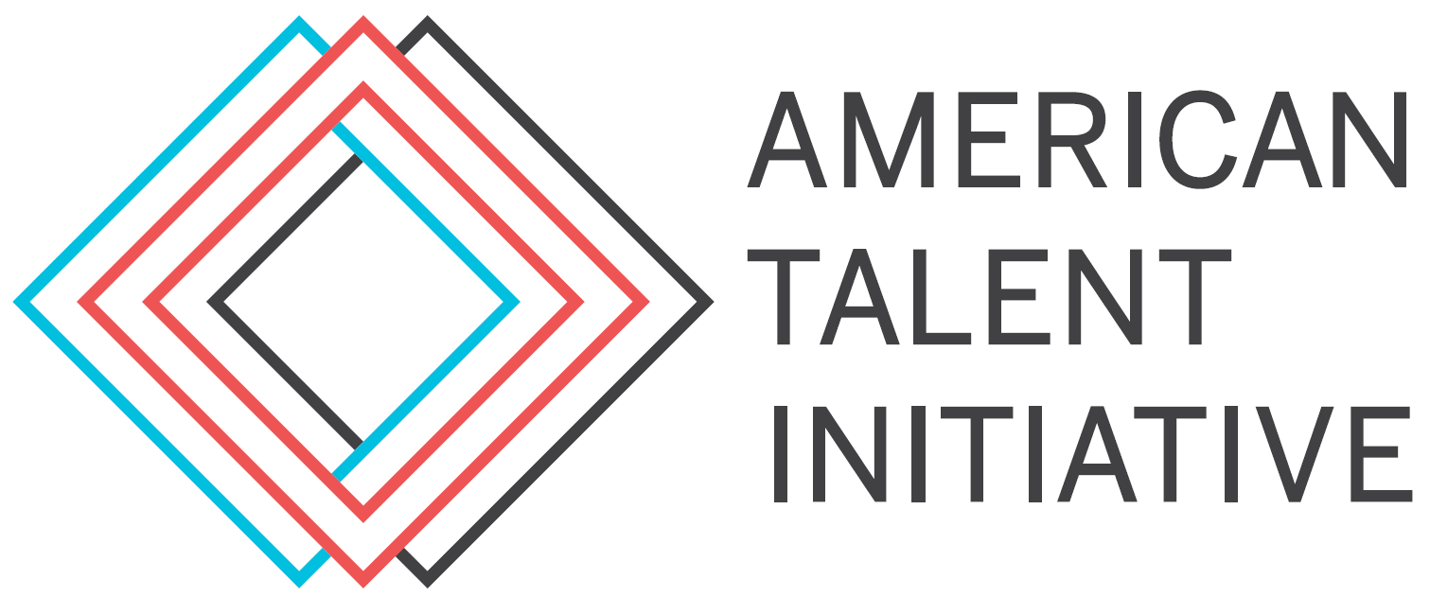

For release on [INSERT DATE]

Media Contacts: [INSERT INSTITUTION CONTACT]
Adam Rabinowitz (Adam.Rabinowitz@aspeninstitute.org, 516-776-8887)

[INSERT NAME OF INSTITUTION] Joins National Initiative to Increase College Access and Success
[INSERT NAME OF INSTITUTION] becomes the newest member of the American Talent Initiative, a collective of 134 colleges and universities devoted to accelerating college opportunity

[CITY, STATE] – Today, [INSERT NAME OF INSTITUTION] announces its membership in the American Talent Initiative (ATI), an alliance of 131 four-year institutions united in a shared goal of enrolling, supporting, and graduating 50,000 additional talented, lower-income students across high-graduation-rate colleges and universities by 2025. ATI's work to increase access and success is more important than ever, especially amid a pandemic that disproportionately impacts talented students from lower-income backgrounds and communities of color.

As a result, [INSERT NAME OF INSTITUTION] sees membership in ATI as a critical opportunity to advance a commitment to supporting students socially, academically, and financially during these times, from before they arrive on campus to graduation and beyond.

[INSERT QUOTE FROM YOUR INSTITUTION'S PRESIDENT/CHANCELLOR ON VALUE OF MEMBERSHIP IN ATI]

ATI works with institutions across the country that graduate at least 70 percent of their students in six years—a threshold that just 334 colleges achieve—to increase the total number of low- and moderate-income students enrolled from about 550,000 to 600,000 by 2025.

In service of this aim, [INSERT NAME OF INSTITUTION] has joined its fellow members in pledging to a public, aspirational goal to increase lower-income student enrollment over the next several years. To realize this pledge, [INSERT NAME OF INSTITUTION] will establish specific goals and strategies to recruit more students from economically diverse backgrounds, increase investments in need-based financial aid, create more equitable student experiences, and ultimately minimize equity-based gaps in retention and graduation rates. [INSERT DETAILS ABOUT SPECIFIC INITIATIVES HERE, IF APPLICABLE]

[INSERT QUOTE FROM YOUR INSTITUTION'S MAIN POINT OF CONTACT ON ACTION STEPS THEY ENVISION TAKING TO REALIZE PROGRESS TOWARD ATI GOAL]

As a member of ATI, [INSERT NAME OF INSTITUTION] will work with more than 130 institutions to share best practices to increase college access and success—and contribute to research that will help other colleges and universities across the country effectively serve students from lower-income backgrounds. A complete list of member institutions is below.

ATI is co-managed by the Aspen Institute College Excellence Program and Ithaka S+R and funded by Bloomberg Philanthropies. For more information about the initiative, you can click here.

###

About [INSERT NAME OF INSTITUTION HERE]:

About The Aspen Institute's College Excellence Program:
The Aspen Institute's College Excellence Program aims to advance higher education practices and leadership that significantly improve student learning, completion, and employment after college—especially for the growing population of low-income and minority students on campuses nationwide. The College Excellence Program is part of The Aspen Institute, a global nonprofit organization committed to realizing a free, just, and equitable society.

About Ithaka S+R:
Ithaka S+R is a not-for-profit service that provides research and strategic guidance to help the academic and cultural communities serve the public good and navigate economic, technological, and demographic change. Ithaka S+R is part of ITHAKA.

About Bloomberg Philanthropies:
Bloomberg Philanthropies invests in 941 cities and 173 countries around the world to ensure better, longer lives for the greatest number of people. The organization focuses on five key areas for creating lasting change: the Arts, Education, Environment, Government Innovation, and Public Health. Bloomberg Philanthropies encompasses all of Michael R. Bloomberg’s giving, including his foundation, corporate, and personal philanthropy as well as Bloomberg Associates, a pro bono consultancy that works in cities around the world. In 2021, Bloomberg Philanthropies distributed $1.66 billion. For more information, please visit www.bloomberg.org or follow us on Facebook, Instagram, YouTube, and Twitter.

ATI MEMBER INSTITUTIONS
(as of December 2, 2022)

Allegheny College | Meadville, PA
American University | Washington, DC
Amherst College | Amherst, MA
Bard College | Annandale-On-Hudson, NY
Barnard College | New York, NY
Baruch College | New York, NY
Bates College | Lewiston, ME
Baylor University | Waco, TX
Boston University | Boston, MA
Bowdoin College | Brunswick, ME
Brown University | Providence, RI
Bryn Mawr College | Bryn Mawr, PA
Bucknell University | Lewisburg, PA
California Institute of Technology | Pasadena, CA
Carleton College | Northfield, MN
Case Western Reserve University | Cleveland, OH
Centre College | Danville, KY
Claremont McKenna College | Claremont, CA
Colby College | Waterville, ME
Colgate University | Hamilton, NY
College of Saint Benedict | Worcester, MA
College of the Holy Cross | St. Joseph, MN
Colorado State University-Fort Collins | Fort Collins, CO
Columbia University in the City of New York | New York, NY
Connecticut College | New London, CT
Cornell University | Ithaca, NY
Dartmouth College | Hanover, NH
Davidson College | Davidson, NC
Dickinson College | Carlisle, PA
Drexel University | Philadelphia, PA
Duke University | Durham, NC
Emory University | Atlanta, GA
Fordham University | New York, NY
Franklin & Marshall College | Lancaster, PA
George Mason University | Fairfax, VA
Georgetown University | Washington, DC
Georgia Institute of Technology-Main Campus | Atlanta, GA
Gettysburg College | Gettysburg, PA
Hamilton College | Clinton, NY
Harvard University | Cambridge, MA
Haverford College | Haverford, PA
Hobart William Smith Colleges | Geneva, NY
Hope College | Holland, MI
Illinois Institute of Technology | Chicago, IL
Illionois State University | Normal, IL
Indiana University-Bloomington | Bloomington, IN
James Madison University | Harrisonburg, VA
Johns Hopkins University | Baltimore, MD
Juniata College | Huntingdon, PA
Kenyon College | Gambier, OH
Knox College | Galesburg, IL
Lafayette College | Easton, PA
Lawrence University | Appleton, WI
Lebanon Valley College | Annville, PA
Lehigh University | Bethlehem, PA
Marist College | Poughkeepsie, NY
Massachusetts Institute of Technology | Cambridge, MA
Miami University-Oxford | Oxford, OH
Middlebury College | Middlebury, VT
Mount Holyoke College | South Hadley, MA
Muhlenberg College | Allentown, PA
New York University | New York, NY
Northwestern University | Evanston, IL
Occidental College | Los Angeles, CA
Ohio State University-Main Campus | Columbus, OH
Pomona College | Claremont, CA
Princeton University | Princeton, NJ
Rhode Island School of Design | Providence, RI
Rice University | Houston, TX
Ripon College | Ripon, WI
Rowan University | Glassboro, NJ
Rutgers University-New Brunswick | New Brunswick, NJ
Saint Mary's College - Notre Dame | Notre Dame, IN
Saint Michael's College | Colchester, VT
Santa Clara University | Santa Clara, CA
Simmons University | Boston, MA
Smith College | Northampton, MA
Southern Methodist University | Dallas, TX
Spelman College | Atlanta, GA
St. Mary's College of Maryland | Selinsgrove, PA
Stanford University | Stanford, CA
Stevens Institute of Technology | Hoboken, NJ
Stony Brook University | Stony Brook, NY
Susquehanna University | Selinsgrove, PA
Swarthmore College | Swarthmore, PA
Texas A & M University-College Station | College Station, TX
Texas Christian University | Fort Worth, TX
The University of Tennessee-Knoxville | Knoxville, TN
The University of Texas at Austin | Austin, TX
Towson University | Towson, MD
Trinity College | Hartford, CT
University of California-Berkeley | Berkeley, CA
University of California-Davis | Davis, CA
University of California-Irvine | Irvine, CA
University of California-Los Angeles | Los Angeles, CA
University of California-Merced | Merced, CA
University of California-Riverside | Riverside, CA
University of California-San Diego | La Jolla, CA
University of California-Santa Barbara | Santa Barbara, CA
University of California-Santa Cruz | Santa Cruz, CA
University of Central Florida | Orlando, FL
University of Chicago | Chicago, IL
University of Dayton | Dayton, OH
University of Delaware | Newark, DE
University of Illinois at Urbana-Champaign | Champaign, IL
University of Iowa | Iowa City, IA
University of Maryland-College Park | College Park, MD
University of Massachusetts-Amherst | Amherst, MA
University of Miami | Miami, FL
University of Michigan-Ann Arbor | Ann Arbor, MI
University of Minnesota-Twin Cities | Minneapolis, MN
University of North Carolina at Chapel Hill | Chapel Hill, NC
University of Notre Dame | Notre Dame, IN
University of Pennsylvania | Philadelphia, PA
University of Pittsburgh-Pittsburgh Campus | Pittsburgh, PA
University of Richmond | Richmond, VA
University of South Carolina-Columbia | Columbia, SC
University of Southern California | Los Angeles, CA
University of Virginia-Main Campus | Charlottesville, VA
University of Washington-Seattle Campus | Seattle, WA
University of Wisconsin-Madison | Madison, WI
Vanderbilt University | Nashville, TN
Vassar College | Poughkeepsie, NY
Wabash College | Crawfordsville, IN
Washington and Lee University | Lexington, VA
Washington University in St Louis | St. Louis, MO
Wellesley College | Wellesley, MA
Wesleyan University | Middletown, CT
William & Mary | Williamsburg, VA
Williams College | Williamstown, MA
Wofford College | Spartanburg, SC
Yale University | New Haven, CT

